Access Modifiers in Java
Access modifiers act like permission rules, controlling where a class, variable, constructor, or method is allowed to be used.

Types of Access Modifiers
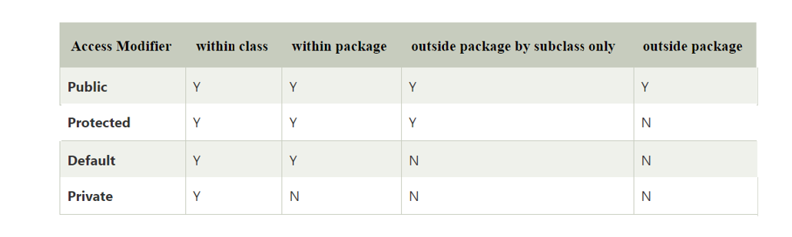
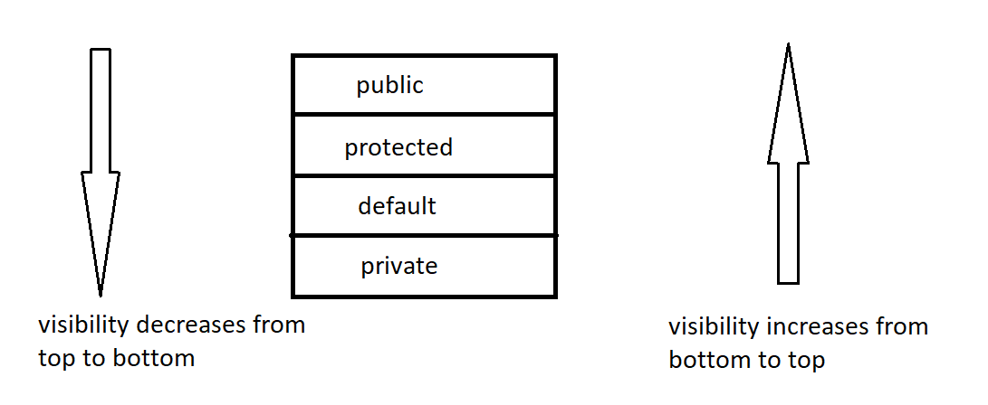

default (no keyword)
🔹 What is default access?
- Default means no access modifier is written
- It is also called package-private
class Test { // default class
int x; // default variable

void show() { // default method
}
}

They can be applied to 👇
1️⃣ Class
- ✔️ Top-level class → public or default only
- ❌ private and protected NOT allowed on top-level classes
- ✔️ Inner classes → all access modifiers allowed

2️⃣ Variables
Access modifiers can be applied to:
✔️ Instance variables
private int age;
✔️ Static variables
public static int count;
❌ Local variables (inside methods, blocks, loops)
void test() {
int x = 10; // ❌ cannot use public/private/protected
}
📌 Why local variables cannot have access modifiers?
Because:
- Their scope is already limited to the method/block
- Access modifiers control visibility between classes, not inside a method

3️⃣ Constructors
✔️ All access modifiers can be applied
public MyClass() {}
private MyClass() {}
📌 Common uses:
- private constructor → Singleton pattern
- public constructor → normal object creation

4️⃣ Methods
✔️ All Access modifiers can be applied
public void show() {}
protected void display() {}
private void helper() {}
void hello(){}

6️⃣ Instance initializer blocks (Java blocks)
{
// ❌ no access modifier allowed
}
📌 Reason
Blocks:
- Are executed automatically
- Are not accessed or called from outside
- So visibility control makes no sense

1️⃣ Method Types in Inheritance
1. Inherited methods
Methods which are inherited from parent class, and child class uses them without any change, are called inherited methods.
Example:
obj.landing();
obj.takeOff();

2. Overridden methods
Methods which are inherited from parent class, and child class changes the implementation (same method signature), are called overridden methods.
Example:
obj.fly(); // different behavior in child

3. Specialized methods
Methods which are present only in the child class and not present in parent class are called specialized methods.
Example:
obj.carryGoods();
📌 Important clarification (missing earlier)
Specialized methods are not polymorphic.
They cannot be accessed using parent reference.
Eg: Inheritance_Method_Types

2️⃣ Overloading vs Overriding
🔹 Rule 1: Method name must be SAME
Overloaded methods must have the same method name.
void add(int a, int b) {}
void add(int a, int b, int c) {}
If method name is different → ❌ NOT overloading.

🔹 Rule 2: Parameter list MUST be DIFFERENT (MOST IMPORTANT)
At least one of the following must differ:
- Number of parameters
- Type of parameters
- Order of parameters
void show(int a) {}
void show(int a, int b) {} // number changed
void show(double a) {} // type changed
void show(int a, double b) {} // order changed
📌 If parameter list is same → ❌ compile-time error (duplicate method).

🔹 Rule 3: Return type ALONE cannot differentiate methods
Changing only return type is not allowed.
int add(int a, int b) {}
double add(int a, int b) {} // ❌ compile-time error

📌 Reason:
Compiler does not use return type to resolve method calls. explain this properly. i mean changing the return type does not matter . there is no rule for return type
Why compiler ignores return type (simple logic)
A method call looks like this:
add(10, 20);
The return type is not written in the call.
So the compiler cannot use it to decide which method to invoke.

🔹 Rule 4: Access modifier does NOT matter
Different access modifiers do not create overloading.
public int add(int a, int b) {}
private int add(int a, int b, int c) {} // ✔️ valid (parameters differ)
But this is ❌ invalid:
public int add(int a, int b) {}
private int add(int a, int b) {} // ❌ duplicate method

🔹 Rule 5: Overloading is resolved at COMPILE TIME
Method overloading is compile-time polymorphism.
add(10, 20); // compiler decides method
add(10, 20, 30);
📌 JVM is NOT involved in choosing overloaded methods.

🔹 Rule 6: Inheritance is NOT mandatory
Overloading can occur:
- Within the same class
- Across parent and child classes
class Parent {
void show(int a) {}
}

class Child extends Parent {
void show(int a, int b) {}
}
✔️ Still overloading because parameters differ.

🔹 Rule 7: Overloading can happen with or without inheritance
Inheritance is optional, not required.
Overloading depends on method signature, not class relationship.

🔹 Rule 8: static methods CAN be overloaded
static void test(int a) {}
static void test(int a, int b) {}
✔️ Valid overloading.

🔹 Rule 9: final methods CAN be overloaded
final void display(int a) {}
final void display(int a, int b) {}
✔️ Valid — final only restricts overriding.

🔹 Rule 10: private methods CAN be overloaded
private void log(int a) {}
private void log(String s) {}
✔️ Valid — visibility has no effect.

🔹 Rule 11: Constructors CAN be overloaded
Constructors follow the same overloading rules.
class Demo {
Demo() {}
Demo(int a) {}
Demo(int a, int b) {}
}
✔️ Very common use case.

🔹 Rule 12: Autoboxing, widening & varargs affect overloading (ADVANCED)
void test(int a) {}
void test(Integer a) {}
void test(long a) {}
void test(int... a) {}
📌 Compiler follows priority:
- Exact match
- Widening
- Autoboxing
- Varargs

Eg: Overloading_All_Rules

⭐ Interview one-liner
“Method overloading is compile-time polymorphism where multiple methods with the same name but different parameter lists coexist; return type, access modifier, and inheritance do not participate in method resolution.”

✅ ALL RULES OF METHOD OVERRIDING (JAVA)

🔹 Rule 1: Inheritance is MANDATORY
Method overriding can happen only in a parent–child relationship.
class Parent {
void show() {}
}

class Child extends Parent {
void show() {} // overriding
}
📌 Without inheritance → ❌ overriding is impossible.

🔹 Rule 2: Method name must be SAME
The child method must have exactly the same name as the parent method.
void display() {} // parent
void display() {} // child
Different name → ❌ NOT overriding.

🔹 Rule 3: Parameter list must be EXACTLY SAME (MOST IMPORTANT)
For overriding:
- Number of parameters must be same
- Types must be same
- Order must be same
void add(int a, int b) {} // parent
void add(int a, int b) {} // child ✔️
📌 If parameters change → it becomes overloading, not overriding.

🔹 Rule 4: Return type must be SAME or COVARIANT
Return type can be:
- Same as parent
- OR a subclass type (covariant return)
class A {}
class B extends A {}

class Parent {
A getObj() { return new A(); }
}

class Child extends Parent {
B getObj() { return new B(); } // ✔️ covariant
}
📌 Applies only to non-primitive return types.

Eg: Co_Variant

🔹 What is Covariant Return Type?
👉 Simple meaning first
Covariant return type means:
When overriding a method, the child class is allowed to return a more specific type than the parent method’s return type.
That’s all.

🔹 First understand the normal return type rule
In method overriding, normally:
- Parent method return type = Child method return type
Example:
class Parent {
Animal getAnimal() {
return new Animal();
}
}

class Child extends Parent {
Animal getAnimal() {
return new Animal();
}
}
✔️ This is normal overriding.

🔹 Now comes the special case → Covariant return type
Java gives extra flexibility.
If:
- Parent method returns a class type
- Child method returns a subclass of that return type
👉 Then overriding is still allowed.
This flexibility is called covariant return type.

🔹 Example (very clear)
class Animal { }

class Dog extends Animal { }
Now overriding:
class Parent {
Animal getPet() {
return new Animal();
}
}

class Child extends Parent {
Dog getPet() {
return new Dog();
}
}
✔️ This is VALID overriding
✔️ This is called covariant return type

🔹 Why is this allowed? (logic)
Because:
Dog IS-A Animal
So wherever an Animal is expected, a Dog can be safely returned.
📌 Java follows IS-A relationship here.

🔹 What is the rule in simple words?
If the return type of the child method is a child class of the parent method’s return type, then overriding is allowed.
That is covariant return type.

🔹 Very important restrictions (INTERVIEW POINTS)
❌ Not allowed for primitive return types
int getValue() {}
long getValue() {} // ❌ NOT covariant
Covariant return types work only with class (object) return types.

❌ Not allowed if there is no IS-A relationship
class A {}
class B {}

class Parent {
A getObj() {}
}

class Child extends Parent {
B getObj() {} // ❌ invalid (no IS-A relation)
}

🔹 Visual understanding (mental model)
Think like this:
- Parent promises: “I will return an Animal”
- Child says: “I’ll return a Dog (which is an Animal)”
✔️ Promise is still kept
✔️ Program remains safe
That’s why Java allows it.

🔹 One-line definition (EXAM / INTERVIEW READY)
Covariant return type allows an overridden method in the child class to return a subclass of the parent method’s return type.

🔹 Rule 5: Visibility cannot be REDUCED
Child method:
- Cannot reduce visibility
- Can increase or keep same visibility
// Parent
protected void show() {}

// Child
public void show() {} // ✔️ allowed
❌ Invalid:
public void show() {}
protected void show() {} // ❌ reduced visibility

🔹 Rule 6: Overriding is resolved at RUNTIME
Method overriding is runtime polymorphism.
Parent ref = new Child();
ref.show(); // Child’s method executes
📌 Method execution depends on object, not reference.

🔹 Rule 7: static methods CANNOT be overridden
Static methods belong to the class, not the object.
class Parent {
static void test() {}
}

class Child extends Parent {
static void test() {} // ❌ method hiding, NOT overriding
}
📌 This is called method hiding, not overriding.

🔹 Rule 8: final methods CANNOT be overridden
final prevents modification.
class Parent {
final void show() {}
}

class Child extends Parent {
void show() {} // ❌ compile-time error
}

🔹 Rule 9: private methods CANNOT be overridden
Private methods:
- Are not inherited
- Belong only to parent class
class Parent {
private void test() {}
}

class Child extends Parent {
void test() {} // ❌ NOT overriding, new method
}
📌 Looks similar, but no overriding happens.

🔹 Rule 10: Exception rule (Checked exceptions)
Child method:
- ❌ Cannot throw broader checked exception (broader = parent exception)
- ✅ Can throw same or narrower exception (narrower = child exception)
- ✅ Can throw no exception
class Parent {
void read() throws IOException {}
}

class Child extends Parent {
void read() throws FileNotFoundException {} // ✔️
}

Rule 11: Unchecked exceptions have no restriction
Runtime exceptions (NullPointerException, etc.)
can be thrown freely.

🔹 Rule 12: Method signature must match exactly
Method signature for overriding means:
- Method name
- Parameter list
Return type & access modifiers have rules, but are not part of signature.

Eg: Overriding_All_Rules_Demo

